

**District 7630 RYLA 2023 Delegate Packet**

**Contents:**

**RYLA Facts and FAQs**

**Delegate Heath/Photo Release/Code of Conduct Form**

**Return pages 4-8 to your Rotary Club sponsor by December 1st**

**Please contact: Phil Reed, District RYLA Chair at** [**gpreed52@hotmail.com**](mailto:gpreed52@hotmail.com) **or 443 521-0100 with your questions**

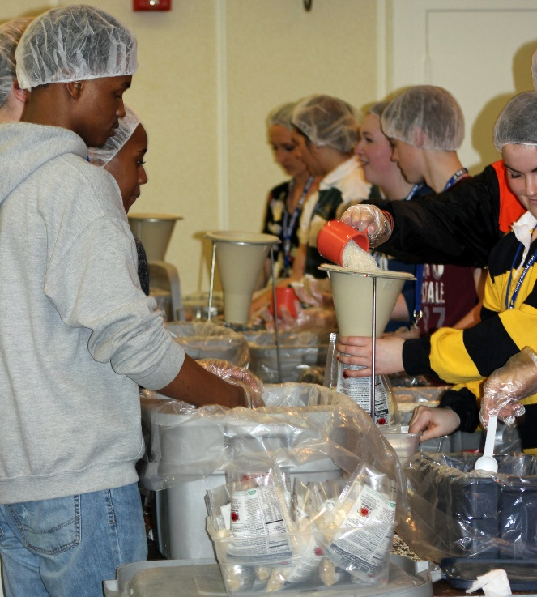

**Packing Meals at RYLA for Rise Up for Hunger**



Facts and FAQs

**What is Rotary Youth Leadership Awards?**

The RI District 7630 RYLA is an intense leadership-training experience designed to recognize, encourage, and further the knowledge and skills of 11th grade high school students who have a demonstrated leadership potential and a heart for community service. District 7630 sponsored its first RYLA in 2013 with approximately 90 delegates. Delegates increased to 120 in 2014 and 130 in 2018.

**What is the Purpose of RYLA?**

RYLA has a number of purposes, including the following:

* To enable promising young leaders to encounter and analyze critical issues of professional and business ethics and to accept responsibility;
* To confront and resolve critical social, cultural, economic, and environmental issues;
* To develop and refine leadership skills;
* To become more acquainted with the business, and professional worlds;
* To meet and make new friends of different racial, social, and cultural backgrounds;
* To learn about Rotary and its many youth oriented programs; and
* To have a FUN learning experience.

**How Does RYLA Related to Rotary?**   
This major, worldwide, youth-related, vocational service program was officially adopted by Rotary in 1971.  
It provides a unique opportunity for Rotary clubs to establish a helping relationship with tomorrow's leaders.  
It is a concrete demonstration of Rotary's respect and concern for young people.  
It publicly recognizes and supports the young people who are rendering service to their peers, schools and communities.  
It offers an opportunity to introduce Rotary to tomorrow’s leaders.  
It introduces these young people to members of Rotaract and Interact.

**What Happens at RYLA?**   
RYLA is an intense weekend of stimulating lectures, discussions, and hands-on learning experiences. The focus is on development of leadership skills and increasing awareness of critical public issues, community concerns, youth-related issues, and service/career opportunities. In addition, there are many supervised recreational and social activities designed to promote healthy interaction and FUN.

**How Is RYLA Staffed?**   
All aspects of the program will be directed by Rotarians and assisted by Rotaractors (college students)and others who belong to Rotoract or Rotary Clubs). Lectures, discussions, and group-interactions will be conducted by expert business leaders and professionals from Rotary and the community.

**How Are Delegates Selected?**

Delegates are selected by their sponsoring Rotary Club. The process should begin with the club’s RYLA Chair contacting their local high school(s) about the RYLA program. Preferably the applicant pool should be two or three times the number of qualified candidates the club will sponsor. **A committee of Rotarians should then interview and select the best-qualified candidates.** One or more alternates should also be selected to cover any last minute cancellations.

**Delegate Selection Criteria**

**Grade:** Students should be 11th grade high school students. Senior and very mature sophomore Interact members will be considered but juniors are preferred.

**The following characteristics are used to select delegates**

**Interact members receive priority**

**Leadership Potential/Experience:** Candidate has demonstrated qualities that make him/her an effective leader. We are particularly interested in students who have identified leadership potential and a heart for community service but have had limited opportunities to lead.

**Academic Ability:** The student consistently maintains at least satisfactory academic performance.

**Extracurricular Activities/Work Experience:** The candidate has been involved in extracurricular activities.

**Questioning Thought:** The candidate thoughtfully considers things he/she reads or hears, and does not blindly accept what is presented.

**Articulation:** The candidate can clearly express his/her ideas both verbally and in writing.

**Ability to Relate with Peers:** The candidate works well with others.

**Receptive to New Experiences:** The candidate is receptive to new ideas and experiences.

**For more information, please contact:**

Phil Reed, District 7630 RYLA Chair- [gpreed52@hotmail.com](mailto:gpreed52@hotmail.com) or 443-521-0100

For **more information** *and* to view a **power point presentation about RYLA**,

see the following websites:

<http://www.rotary7630.org/>

[www.rotary.org/RYLA](http://www.rotary.org/RYLA) and

FaceBook @RYLA District 7630



***District 7630 Rotary Youth Leadership Award (RYLA) Conference***

**Health – Photo Release - Code of Conduct**

**This five-part form requires signatures at the end of each section.**

**Section 1 – Health Form – *Please type or print clearly clearly***

RYLA Delegate’s Full Name ______________________________________________________

What first name would you like on your name tag? ____________________________________

Age ____ Birth date ___/____/_______ Gender: Male ___ Female___

Email Address _____________________________________ Cell Phone # _____ ____-_______

Address ______________________________________________________________________

City/Town ______________________________________________ State _____ Zip _________

Name of Parent or Guardian ______________________________________________________

Cell Phone ___________________ Home Phone ________________ Work Phone ___________

Name of 2nd Parent/Guardian/Responsible Family Member _____________________________

Cell Phone ___________________ Home Phone ________________ Work Phone ___________

If neither of above is available, in an emergency call ___________________________________

Cell Phone ___________________ Home Phone ________________ Work Phone ___________

**Health Insurance Information**

Policyholder’s name __________________________________________________________

Relationship to RYLA delegate _________________________________________________

Insurance Company Name _____________________________________________________

Insurance Company Address ___________________________________________________

IF HMO, Emergency Treatment Authorization Phone _______________________________

Employer’s Name and Address _________________________________________________

Policy Number(s) ___________________________________________________________

Please check yes or no to the following. (If yes, explain; attach an additional page if necessary).

**Yes No**

___ ___ Recent surgeries or factures _______________________________________________

___ ___ Chronic health problems (seizures, asthma, etc.) _______________________________

___ ___ Acute illness ___________________________________________________________

**Health Information Page 3**

Please check yes or no to the following. (If yes, explain; attach an additional page if necessary).

**Yes No**

___ ___ Recent treatment for kind of medical problem _________________________________

___ ___ Allergies to medication or local anesthetics ___________________________________

___ ____ Recent surgeries or factures ______________________________________________

___ ___ Chronic health problems (seizures, asthma, etc.) ______________________________

___ ___ Acute illness ___________________________________________________________

___ ___ Recent treatment for kind of medical problem ________________________________

___ ___ Allergies to medication or local anesthetics __________________________________

___ ___ Contacts, glasses or orthodontic appliances ___________________________________

___ ___ Immunizations are up-to-date

___ ____Date of last tetanus shot: ____/______/___________

____ ____COVID Shots and Booster (Not required, for emergencies only)

**Please list all allergies to medications** (food allergies are listed in Section 4)

**Medications currently being taken:**

**Name Dosage Frequency**

**Parents:** Please share with us anything about your child you feel could be helpful or necessary for us to know to improve his/her conference experience (For example: nervous stomach, motion sickness, nose bleeds, ear aches, sleepwalking, etc.)

Parents: Please list any conference activities in which your child may **not** participate: ________

**Health Information Page 3**

I understand my child may require medication for minor medical conditions including headaches, upset stomach, cuts and scrapes, etc. The following over-the-counter medications may be administered to my child, as needed, following suggested dosage guidelines provided by the manufacturer. **Initial below all medications you give permission for your child to receive.**

**_____ Tylenol** for headaches, muscle aches and pains, cramps

**_____ Advil** for headaches, muscle aches and pains, cramps

_____ **Maalox, Mylanta** for upset stomach, stomachache, gas, nausea

_____ **Tums** for stomachache, upset stomach, nausea

_____ **Immodium** for diarrhea

_____ **Pepto-Bismol** for nausea, diarrhea

_____ **Milk of Magnesia** for constipation

_____ **Neosporin, Hydrogen Peroxide** for scrapes and cuts

_____ **Benadryl** (oral) for sinus, allergies, hay fever, rashes

_____ **Sore throat spray or lozenges**

_____ **Robitussin DM**

I understand any **Prescription Medication** brought to the conference **MUST** be in the original container from the pharmacy with the original label and directions attached (or a copy of the prescription from the doctor). All medications (both prescription and OTC) will be turned in at registration, kept securely, and made available as needed/requested.

**Authorization for Treatment:** I hereby give permission to medical personnel to order X-rays, routine tests, treatment, and permission to release any record necessary for insurance purposes, and to provide and arrange necessary related transportation for my child listed above. If I cannot be reached in the event of any emergency, I hereby give my permission to the physician to secure and administer treatment including hospitalization for my child listed above. This complete form may be photocopied should my child need to leave the conference.

The health history I have provided for my child listed above is correct and complete to the best of my knowledge.

**Parent/Guardian Signature** ______________________________________ **Date** _________

I have reviewed my health record and find it to be correct and complete to the best of my knowledge. I agree to provide all medications (prescription and OTC) at registration and will request medications as needed. I also agree to not participate in any activities my parent or guardian has listed on page 6 of this health form.

**Delegate Signature** ______________________________________________ **Date** _________

**Section 2 – Photo Release**

I authorize RYLA, Rotary District 7630 and/or Rotary International, to record and photograph my image and/or voice, for promotional purposes. I understand and agree that these audio, video, film and/or print images may be edited, duplicated, distributed, reproduced, broadcast and/or reformatted in any form and manner without payment or fees, in perpetuity.

**Delegate Signature** ___________________________________________ Date _____________

**Parent/Guardian Signature** ____________________________________Date _____________

**Section 3 – Code of Conduct**

1. RYLA is an **alcohol-free, drug-free, tobacco-free** conference. There is a **Zero Tolerance Policy** in effect for possession of all illegal and prohibited items on the grounds, parking lots, and streets surrounding the Carousel Hotel property. The discovery of illegal items will automatically result in a call to the police and the parents of offender(s).

2. For the safety and privacy of all participants, delegates are prohibited from entering any cabin other than their own. Room assignments are made to maximize the opportunity for interaction with new fellow leaders and will not be changed.

3. Delegates will respect one another, the RYLA staff, guests, camp employees, and themselves with appropriate language, dressing properly (clothing with sexually suggestive, offensive or provocative messages are prohibited), being on time for scheduled activities, being quiet afterhours, and participating fully in all parts of the conference. **The use of electronic devices, including cell phones, music players, video games, etc. is prohibited during scheduled events.**

4. Do not bring valuables (expensive clothing and jewelry, electronics and computers, large amounts of cash, etc.) to the conference. Please report any missing items immediately to RYLA staff but understand the RYLA Staff, Rotary District 7630, Rotary International, and the Carousel Hotel staff will not be responsible for losses of personal property.

5. A delegate driving him/herself to the conference **must submit written parental permission prior to the conference** and surrender all vehicle keys at registration. Vehicle access is prohibited during the conference. Parental permission must be received prior to the conference for a delegate to ride with another delegate driving him/herself.

6. Delegates will be respectful of the Carousel Hotel property by obeying all posted instructions and directions. Repair costs for property damages will be billed to those responsible for the damages. The use of candles, incense, fireworks and anything else that could result in property damage is prohibited.

I have read and understand the RYLA Code of Conduct and agree to all conditions.

**Delegate Signature** _______________________________________________Date __________

**Parent/Guardian Signature** ________________________________________Date _________

**Section 4 - Delegate Information**

**Delegate Full Name** _____________________________________________________

**High School:** _______________________________________________ **Grade** _____

**Rotary Club Providing Scholarship:** _______________________________________

**Are you an Interact member?** Yes ___ No ___

If there is no Interact Club at your school, would you like to help start one? Yes__ No__

**Section 5 – T-Shirt, Food, Driving to/from Conference**

**RYLA T-SHIRT** Size: S___ M___ L___ XL___ 2XL___

**Please list any food allergies:** ___________________________________________

**Meals** All meals are served buffet style except Saturday Dinner. Choose an entrée:

**SATURDAY DINNER**: Please check one:

Chicken Caprese_ __ Penne Abruzzi Primavera __ (Vegetarian)

**Special Meal Requests:** Vegetarian ___ Vegan ___ Other ______________________

**DELEGATE DRIVING PERMISSION**

I give my child (listed above) permission to drive to RYLA and understand that the delegate agrees to have no access to his/her vehicle during the conference and will turn in vehicle keys at registration. I also agto assume all responsibility for any injuries to my child and/or damage to the vehicle driving to or from RYLA.

I give permission for my child to transport another delegate(s): Yes ___ No ___

**Signature of Parent** ____________________________________________________

**RIDING WITH ANOTHER DELEGATE** (not required if riding with a delegate’s parents).

I give my permission for my child (listed above) to ride to RYLA will another delegate who is driving himself/herself. I agree to assume all responsibility for any injury incurred riding to or from RYLA with another delegate.

My child will be riding with delegate _______________________________________

**Signature of Parent** ____________________________________________________