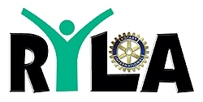

**District 7630 RYLA 2023 CLUB Packet**

**Contents:**

**Club President’s Letter**

**Club Commitment Form**

**RYLA Facts and FAQs**

**Delegate Heath/Photo Release/Code of Conduct Form**

**(Please give just the Delegate Packet to your students)**

**Please contact: Phil Reed, District RYLA Chair (Cambridge Rotary Club) at** [**gpreed52@hotmail.com**](mailto:gpreed52@hotmail.com) **or 443 521-0100 with your questions or suggestions.**

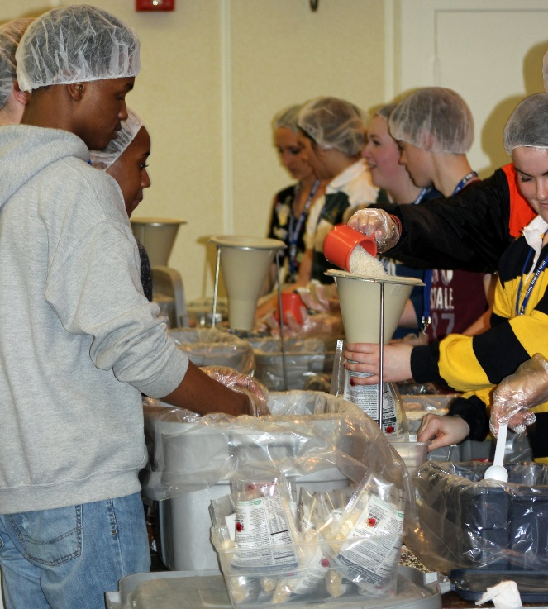

**Packing Meals at RYLA for Meals of Hope**

**Rotary International District 7630**

**Rotary Youth Leadership Awards (RYLA)**

**February 17-19, 2023**

**Dear Rotary Club President:**

On behalf of the District 7630 RYLA Committee, we are pleased to provide the following important RYLA 2022 information including the Rotary Club Commitment Form, Delegate Registration form (health, photo release and code of conduct) and RYLA Basic Facts. The **Club Commitment Form Deadline is November 1.**

Important dates and information:

* **Dates:** Friday 2/17/23 at 6pm through Sunday 2/19/23 late afternoon after presentations
* **Location:** Carousel Hotel, 11700 Coastal Highway, Ocean City, MD 21842
* **Club Registration Form:** Deadline **November 1, 2022**

(A check in the amount of $290 per student must accompany the form). The completed form and payment confirms the reservation for your student(s) to attend RYLA 2019.

* **Payment:** Please make your check payable to RI District 7630 and write RYLA on the memo line. Mail the form and check to: Phil Reed, 111 Lee Drive, Cambridge, MD 21613.
* **Delegate Registration Form:** Deadline **December 10, 2022**. Please send pages 4 – 8 as a single-sided email attachment to: Debra Langseth at debra@chesterwye.com
* **Student Recruitment Assistance:** If your club wants to sponsor one or more delegates and is unable to recruit students, we will be happy to locate students for you. We always have students who want to attend RYLA who need sponsors.

RYLA delegates will learn valuable leadership and communication skills, conflict resolution, business ethics, how to plan and manage a project, and will receive an introduction to Rotary, Interact and Rotaract as well as Rotary International.

RYLA provides an excellent opportunity for your club to be engaged in the Youth Services Avenue of Service. Please make a positive impact on our community’s youth by supporting Rotary District 7630 RYLA.

Email is your best option for contacting me at gpreed52@hotmail.com. You are also welcome to call me at 443 521-0100.

Yours in Rotary Service,

Phil Reed, RYLA Chair

Rotary District 7630



Facts and FAQs

**What is Rotary Youth Leadership Awards?**

The RI District 7630 RYLA is an intense leadership-training experience designed to recognize, encourage, and further the knowledge and skills of 11th grade high school students who have a demonstrated leadership potential and a heart for community service. District 7630 sponsored its first RYLA in 2013 with approximately 90 delegates. Delegates increased to 120 in 2014 and 130 in 2018.

**What is the Purpose of RYLA?**

RYLA has a number of purposes, including the following:

* To enable promising young leaders to encounter and analyze critical issues of professional and business ethics and to accept responsibility;
* To confront and resolve critical social, cultural, economic, and environmental issues;
* To develop and refine leadership skills;
* To become more acquainted with the business, and professional worlds;
* To meet and make new friends of different racial, social, and cultural backgrounds;
* To learn about Rotary and its many youth oriented programs; and
* To have a FUN learning experience.

**How Does RYLA Related to Rotary?**   
This major, worldwide, youth-related, vocational service program was officially adopted by Rotary in 1971.  
It provides a unique opportunity for Rotary clubs to establish a helping relationship with tomorrow's leaders.  
It is a concrete demonstration of Rotary's respect and concern for young people.  
It publicly recognizes and supports the young people who are rendering service to their peers, schools and communities.  
It offers an opportunity to introduce Rotary to tomorrow’s leaders.  
It introduces these young people to members of Rotaract and Interact.

**What Happens at RYLA?**   
RYLA is an intense weekend of stimulating lectures, discussions, and hands-on learning experiences. The focus is on development of leadership skills and increasing awareness of critical public issues, community concerns, youth-related issues, and service/career opportunities. In addition, there are many supervised recreational and social activities designed to promote healthy interaction and FUN.

**How Is RYLA Staffed?**   
All aspects of the program will be directed by Rotarians and assisted by Rotaractors (college students or members of a Rotary sponsored Rotaract Club). Lectures, discussions, and group-interactions will be conducted by expert business leaders and professionals from Rotary and the community.

**How Are Delegates Selected?**

Delegates are selected by their sponsoring Rotary Club. The process should begin with the club’s RYLA Chair contacting their local high school(s) about the RYLA program. They should inform the school of the number of students the Rotary Club wishes to sponsor and ask for their help in providing a pool of potential candidates. Preferably this pool should be two or three times the number of qualified candidates the club will sponsor.

**Delegate Selection Criteria**

**Grade:** Students should be 11th grade high school students. Senior and very mature sophomore Interact members will be considered but juniors are preferred. **A committee of Rotarians should then interview and select the best-qualified candidates.**

While being a member of an Interact Club is not a requirement, if your Rotary Club sponsors an Interact Club, Interact candidates are given first priority. Other candidates are encouraged to be nominated. One or more alternates should also be selected to cover any last minute cancellations. The Centreville Rotary Club has developed a comprehensive RYLA delegate selection process that is available to other clubs.

**When selecting your delegates, please consider the following:**

**Leadership Potential/Experience:** Candidate has demonstrated qualities that make him/her an effective leader. We are particularly interested in students who have identified leadership potential and a heart for community service but have had limited opportunities to lead.

**Academic Ability:** The student consistently maintains at least satisfactory academic performance.

**Extracurricular Activities/Work Experience:** The candidate has been involved in extracurricular activities.

**Questioning Thought:** The candidate thoughtfully considers things he/she reads or hears, and does not blindly accept what is presented.

**Articulation:** The candidate can clearly express his/her ideas both verbally and in writing.

**Ability to Relate with Peers:** The candidate works well with others.

**Receptive to New Experiences:** The candidate is receptive to new ideas and experiences.

**For more information,** and to **view a power point presentation about RYLA**,

see the following websites:

<http://www.rotary7630.org/> [www.rotary.org/RYLA](http://www.rotary.org/RYLA) and FaceBook @RYLA District 7630



**Rotary International District 7630**

**Rotary Youth Leadership Awards (RYLA) Conference**

**February 17-19, 2023 Carousel Hotel Ocean City, MD**

**Rotary Club RYLA Commitment**

**Rotary Club: __________________________________________________________________**

**We will sponsor (number of students): _______**

**Cost Per Student: $ 290.00**

**Total Amount Enclosed $______**

(**Make Check Payable to RI District 7630**

***Please write RYLA on the memo line)***

**Transportation is the responsibility of the delegate’s family**

Clubs are encouraged to offer transportation for their delegates, especially on Friday. We don’t want to exclude delegates whose parents are unable to provide their transportation.

Rotary Club RYLA Contact Information

*See below*

Due November 1, 2022

Rotary Club RYLA Contact Information

Due October 15, 2022

Club President:

Please identify a club member as your club’s RYLA Contact. This individual will receive all the important RYLA information. Select a member who uses email on a daily basis, as all communication will be electronic. The club contact should be willing to go the high schools served by your Rotary Club. He/she should work with the school administration and guidance department to select delegates to attend RYLA.

Please submit delegate forms by December 10th.

Name of Club RYLA Contact: ______________________________________________

Work Phone: _____ - ______ - __________ Cell: _____ - _____ - ________________

Home Phone: _____ - ______ - _________

Email address ___________________________________________

|  |
| --- |
| **Please mail the completed form and payment by December 1st to:**  **Phil Reed, RYLA Chair**  **111 Lee Drive**  **Cambridge, MD 21613**  **This form and your check (payable to RI District 7630) will serve as the reservation for your student(s) as indicated above. If you are unable to confirm a student(s), you may request a refund by 12/15, or request your funds be used as a scholarship for a student the RYLA Committee will identify. We usually have a large list of students who want to attend RYLA but do not have a sponsor. We always attempt to fill vacant spots with scholarship students. It is our goal to have as many students as possible experience RYLA.**  **No Refunds after 12/15. Alternates may be added/substituted until January 31st.** |